UI Brief
Main Menu
Requirements
- Logo
- Box Art
- Buttons
  - Start Game
  - Continue
  - Abandon Run
  - Settings
  - Quit Game
Box Art
Buttons
Logo

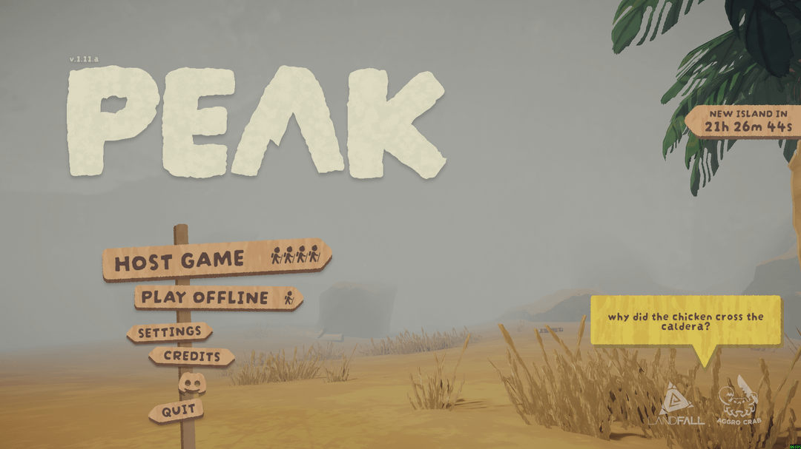
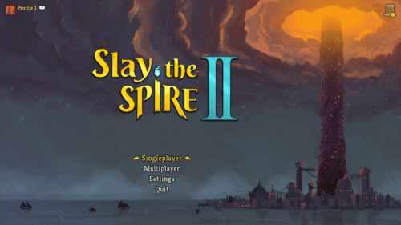
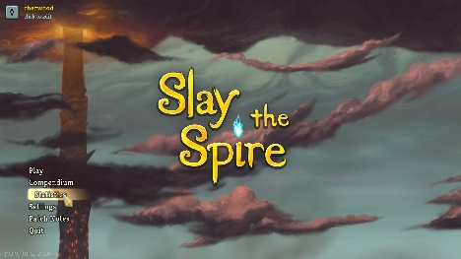
Example.

First Event Room
Requirements
- Text Box
- Button (Will be used for every button in-game)
  - Default
  - Hover
  - Click animation
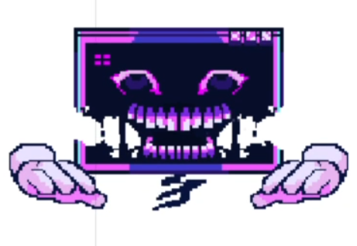
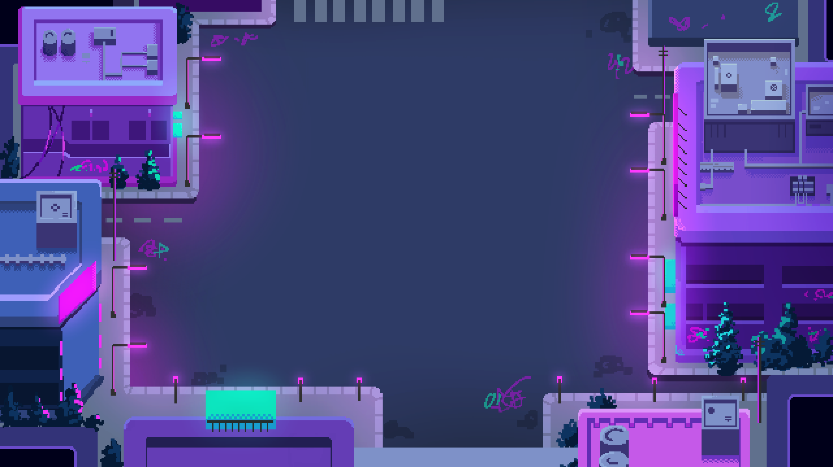

Text Box

Buttons Choice 1
Buttons Choice 2

Buttons Choice 3

Example
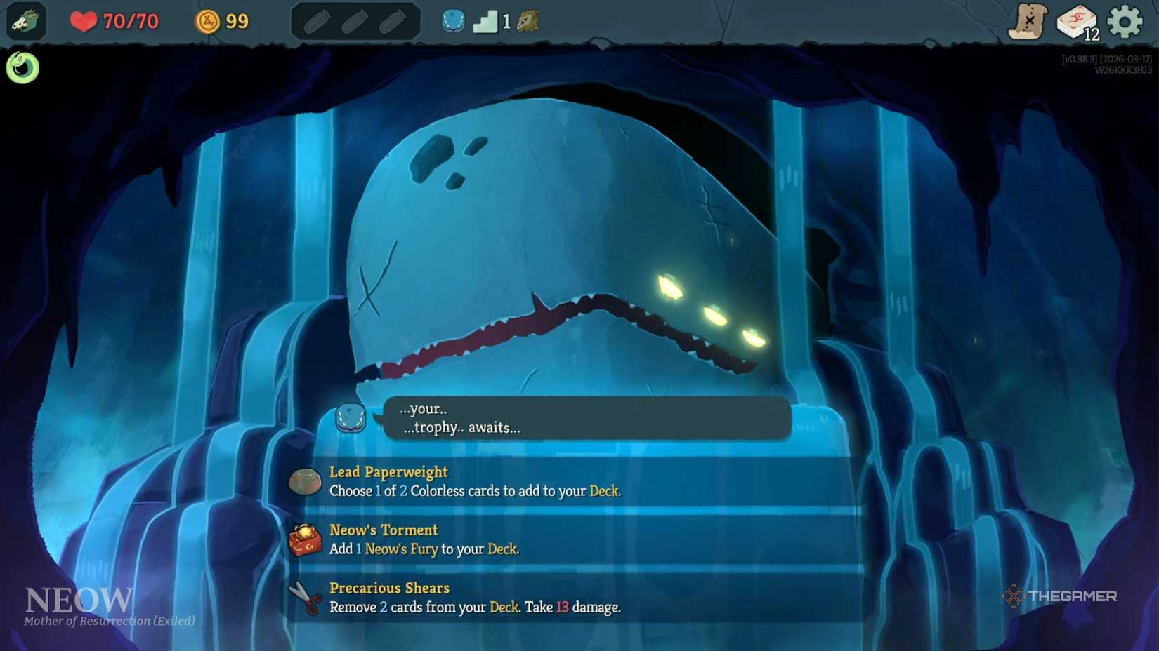
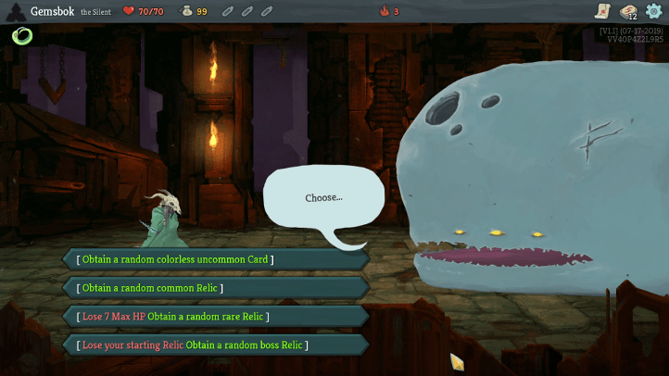

Reward Screen
Requirements
- Backboard (with Loot banner up top)
- Card Reward Icon (Normal and Legendary)
- Currency Icon

- Skip Button
Icons
30 Coins
Add a card into your deck
Icons
Backboard

Skip Button

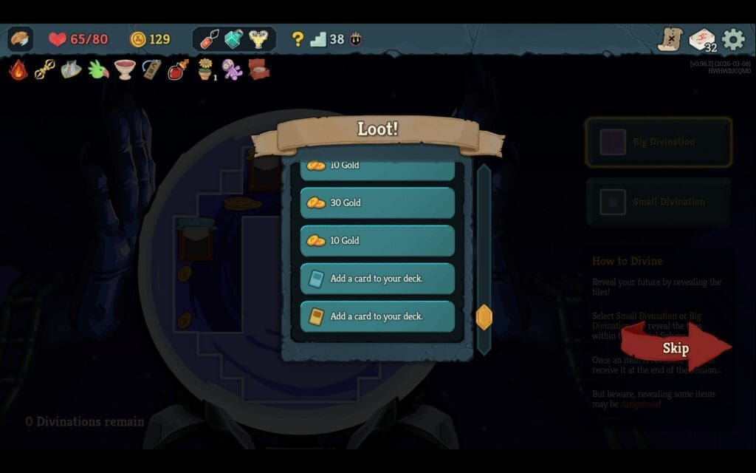
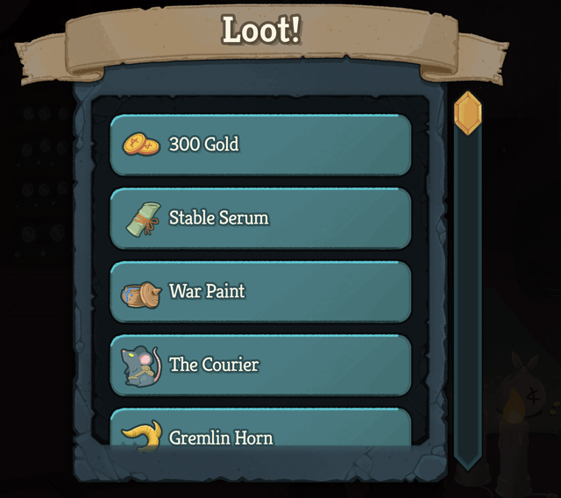
Example
Icon example



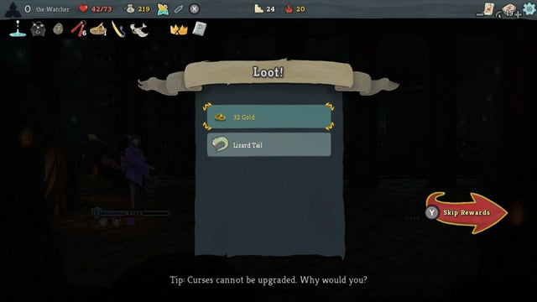



Card Reward
Requirements
- Skip Button

- Choose a card banner
Skip Button
Choose a Card Banner

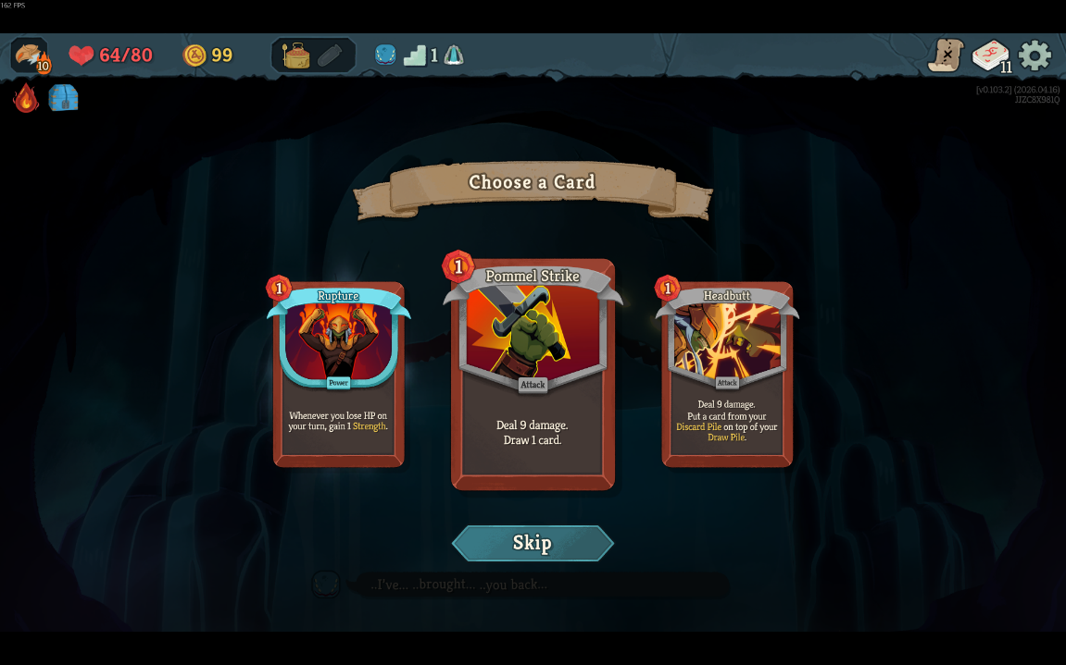
Example

Shop
Requirement
- Leave Button
- Remove a Card Button
- Heal button
- Backboard
- Shop Banner

Shop
Remove a card
Leave Button

Heal

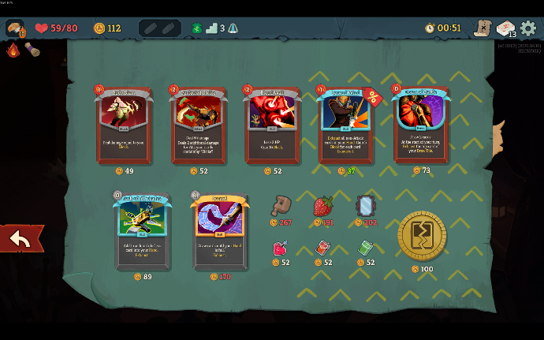
Example
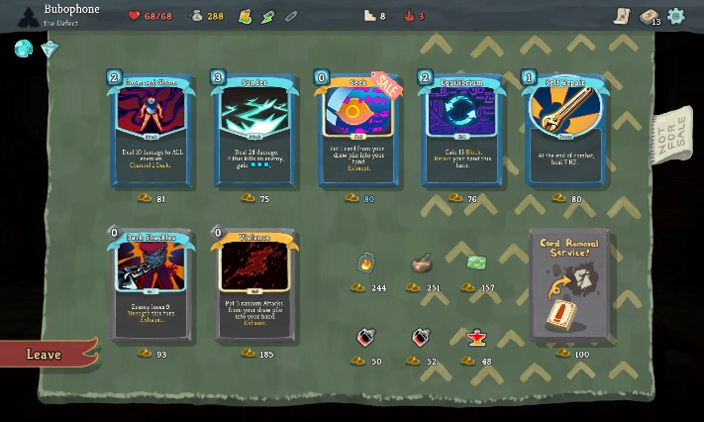

Map Icons
Requirements
- Icons
  - Shop
  - Combat
    - Normal
    - Elite
    - Boss
Example
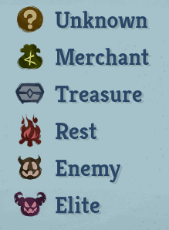

Pause Screen
Requirements
- Buttons
  - Resume
  - Settings
  - Abandon Run
  - Save & Quit to MainMenu

  - Save & Quit to Desktop
Resume
Setting
Abandon Run
Save and Quit to Main menu
Save and Quit to Desktop
Pause

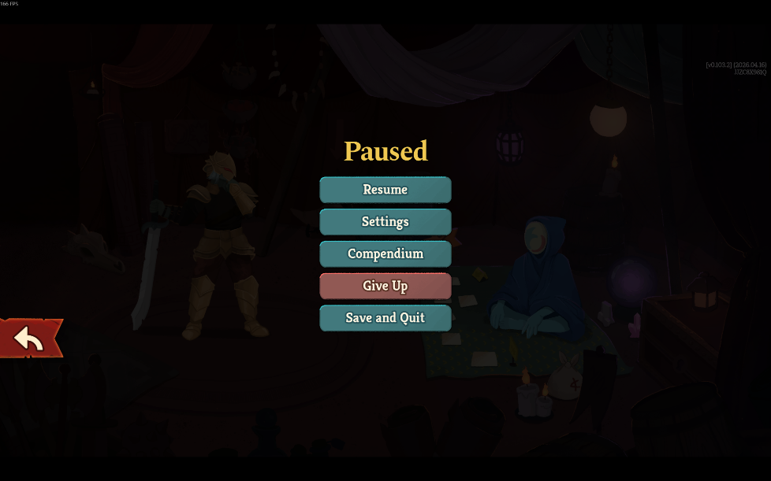
Example

Setting Screen
Requirements
- Icons
  - Sound
  - Music
  - Screen Resolution
  - X
- Slider
  - Bar
  - Pieces

- Backboard
- Buttons
  - Arrow Left/Right
  - Back

  - Apply
Back
Apply

1920 x 1080
BGM
SFX
Screen Resolution
Icons
Icons
Icons
Setting

